

SUPERIOR UNIVERSITY LAHORE
GOLD CAMPUS

NAME: MUHAMMAD MOIZ RAZA
ROLL NO: SU92-BSAIM-F24-061
PROGRAM: ARTIFICIAL INTELLIGENCE
SEMESTER: 4th SEMESTER
SECTION: BSAI-4A
SUBJECT: PROGRAMMING OF AI (LAB)

Submission Title: LAB TASK 8
Submitted To: Sir Rasikh Ali

TITLE: News app using flask (Backend + Frontemd)

OVERVIEW:
It is a simple web application built using flask that fetches live news from newsapi.org and displays it on a webpage. it is designed to show headlines from various categories and update automatically with the latest news.

Technologies Used
• Python – Main Language For Backend
• Flask – Web Framework To Handle Routes And Templates
• Requests – Fetch Live News From Newsapi.Org
• Html & Css – Frontend Structure And Styling
• Newsapi.Org – Provides Real-Time News Via Api

Working
The app fetches live news from different categories using a newsapi key and displays them on a web page. users can switch between sections like business, sports, or technology, and the page updates dynamically to show relevant headlines. flask handles the web server while requests retrieves the data, and the current category is highlighted for easy navigation.

Frontend integration
the frontend is built using html templates rendered by flask. categories are displayed as clickable links, letting users filter news by topic. flask passes the news data to the templates, which then display it dynamically. basic css styling keeps the interface clean and readable. this setup shows how backend and frontend work together in a practical web app.

Features
• fetches real-time news from newsapi.org
• displays headlines, descriptions, and links
• category navigation for general, business, sports, health, science, technology, entertainment
• interactive web interface using flask and html/css
• dynamic highlighting of the selected category

Uses:
• keeps users updated with the latest news
• demonstrates how to fetch and display api data using flask
• can serve as a foundation for more advanced news aggregator applications
LinkedIn
Profile Link: https://www.linkedin.com/in/moiz-raza24/
Project Link: https://www.linkedin.com/in/moiz-raza24/overlay/Project/1217641516/treasury/?profileId=ACoAAGTqlDgBH9cJJWJ6MC7HlteDQeOv3IPURfg
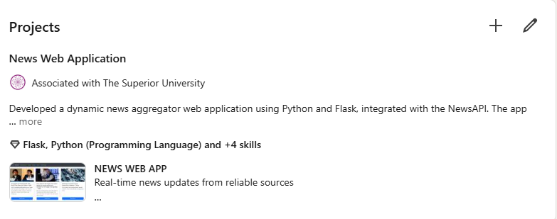

SCREENSHOT
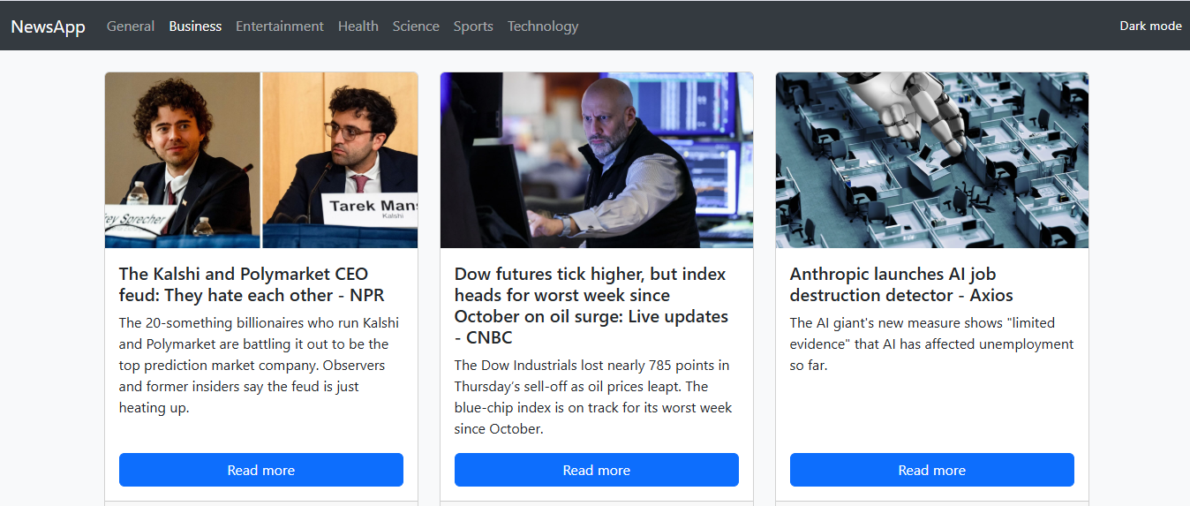

THE END

